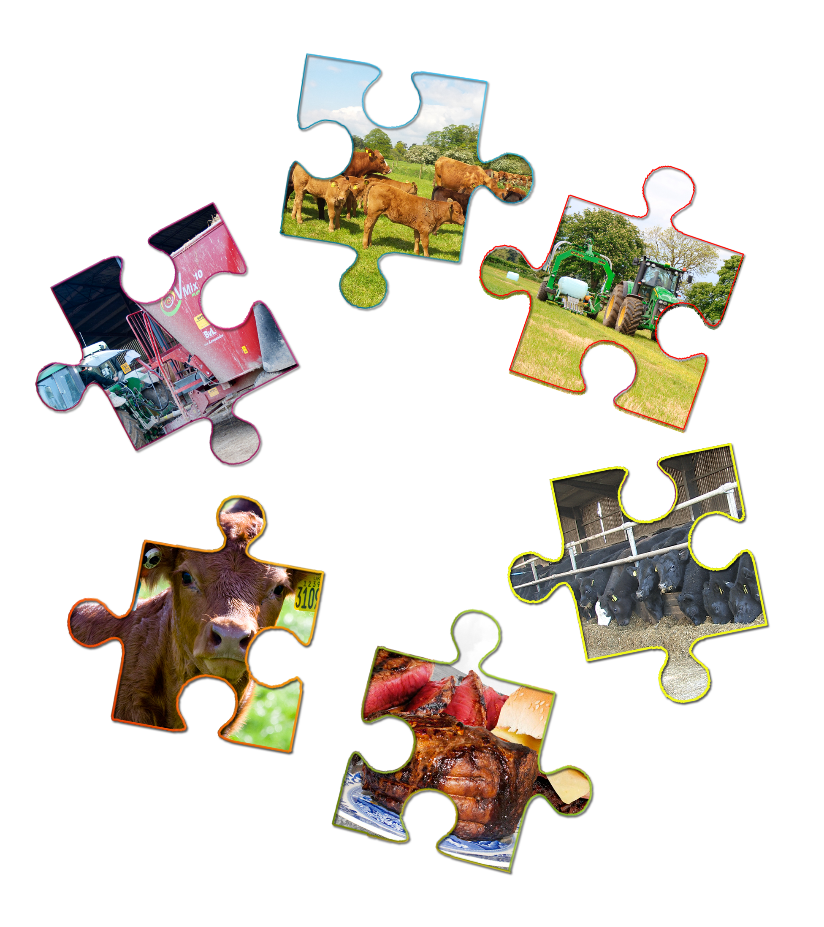
Piecing together....
Beans pulses eggs fish meat & other protein food story.

Beef Food Story

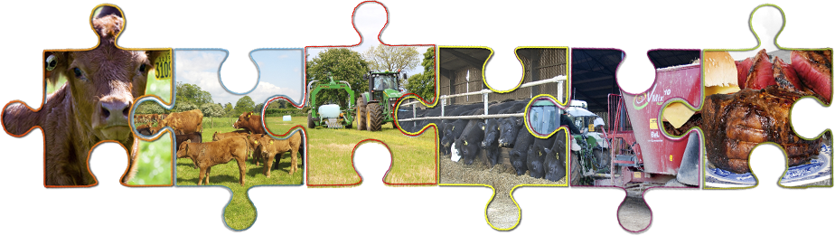
Your Name
GCSE Food Preparation & Nutrition
Teacher’s Name

Food provenance – Beef food story
Today’s Learning
- Describe the stages of the beef food story.
- Describe what selective breeding is.
- Explain how farmers use selective breeding to protect the environment.
- Explain why British beef that is grass fed is good for our food security
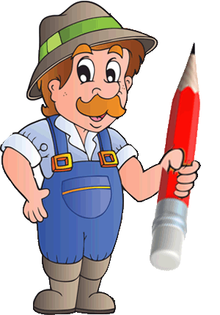
Explain how protecting the environment makes beef production sustainable. Your task is to watch the videos at:
http://discovering-our-countryside.co.uk/beeffoodstory/
Then answer the questions for each video

Year in the Life of a Beef Cow - Intro
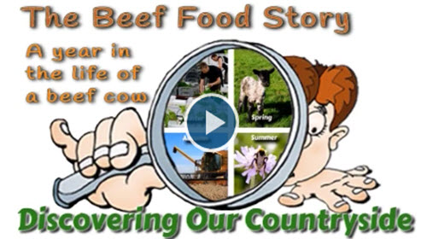
Watch Beef Intro Video
A healthy diet needs to include foods from the beans, pulses, fish eggs meats and other proteins Eat Well group. These foods are a good source of protein, plus (Q1) _______________________________________
(Choose from: fats, vitamins & minerals, carbohydrates. oils )
Bean and pulse crops grown for protein are grown in a very similar way to the cereal crops shown in the Cereals Food Story. For the eat well harvest of Beans, Pulses, Fish, Eggs and Meat we will look at one of the meats – beef and see how cattle are reared in the UK.
We also keep cows for their milk – the two ways of keeping cows are called
(Q2) _______________________________________
(Choose from: beef, meat, dairy, suckler, draft ) Cows = milk
(Q3) _______________________________________
(Choose from: smelly, meat, dairy, beef, draft ) Cows = meat
Cows are mammals just like us which means they produce milk for their young. To do this they must have a (Q4) _______________________________________
(Choose from: drink, udders, horns, calf, ) first.
With Beef cows we raise this calf for meat and allow the calf to drink or suckle (= sucker cow) its mother’s milk for the first few months of its life
With Dairy cows we want the milk rather than the calf so we raise the calf on (Q5) _______________________________________
(Choose from: substitute milk, other food, grass, cereals) and collect the cow’s milk by milking her each day. Some of the calves from a dairy cow are raised and then used as milking cows.
Some of the dairy cows calves are raised for beef – the beef they produce is no different to that of a calf from a beef cow but because they are really breed for milk they can take longer to reach a suitable slaughter weight and so are less profitable for a farmer.
We will follow the year in the life of a beef cow – starting in Autumn when you start a new school year.

Year in the Life of a Beef Cow - Autumn
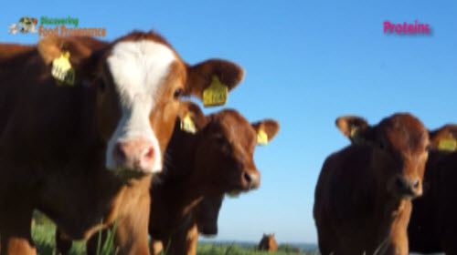
Watch A Beef Cow Autumn Video
These beef or suckler cows had a calf in spring.
By mid summer the calf no longer needs its mother’s milk as it is now (Q6) _______________________________________
(Choose from: quite old, sick of milk, running around, eating grass) but it would still drink as much as it could if given the chance.
Producing milk is very demanding on a mothers body. So the calf is weaned by moving it to a separate field.This gives the cow a chance to (Q7) _______________________________________
(Choose from: relax, produce milk for us, eat grass, recover) from producing all that milk by eating as much grass as she can…
And as she is also hopefully pregnant with her next calf her body can concentrate on feeding this new calf growing in her womb
UK reared beef cattle spend a large part of their life (Q8) _______________________________________(Choose from: in large pens with no access to grass, out in the fields grazing grass, laying down ) Much of this land is too wet, stony or hilly to be used to grow crops. But it can be used for producing quality protein which is good for the country’s (Q9) _______________________________________ (Choose from: (image, healthy, food security, football teams ) Being largely grass fed also makes British Beef a more sustainable product than that from other countries whose methods of production are often much more (Q10) _______________________________________(Choose from: ( expensive, cow friendly, intensive, humane )
Some people refer to such methods as factory farming as they do not allow cattle any access to green fields. Whilst factory farms are often viewed negatively their purpose is to produce as much food as possible as (Q11) _______________________________________(Choose from: dangerously, unhealthily, efficiently, inhumanly ) as possible.
It is up to the consumer to decide if food produced in such a way is acceptable. Look for the (Q12 _______________________________________(Choose from: British Flag, Farm Name, Red Tractor Logo) on meat to know if it has been produced in the UK to high welfare standards

Year in the Life of a Beef Cow – Winter
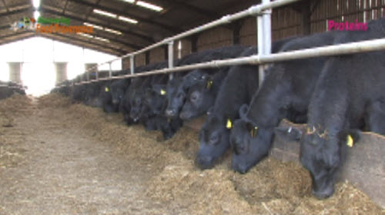
Watch A Beef Cows Winter Video
As autumn turns to winter the grass stops growing and the fields can become very (Q13) _______________________________________
(Choose from: cold, empty, yellow, wet and waterlogged )
So they have enough food especially the pregnant cows and to stop the fields becoming muddy and the grass being killed cattle are brought inside and housed over the winter.
These cattle are being brought in, rather than chase the cows around which would not be good for their unborn calves...– the farmer is trying to lure them out of the field by letting them see their food – see if it works?
As well as the bulls and pregnant cows, this years calves plus calves from the previous spring are housed over the winter.
(Q14) Select which groups of cattle the farmer will house over winter _______________________________________ (Choose from: Pregnant cows, calves less than 1 year old, calves over 1 year old, bulls. )
Whilst most of the calves are kept for beef, some of the calves will be kept as (Q15) _______________________________________ (Choose from: Pets, to help eat the grass, replacement breeding cows) These replacement cows that have not yet had their first calves are called heifers. Heifers are to replace any adult cows that have become too old to have any more calves usually by about 12 years old when hopefully they will have had (Q16) _______________________________________(Choose from: 8, 5, 6, 12, 10) calves
The farmer must feed all these cattle whilst they are inside. Just like you cattle have to have (Q17) a_______________________________________ (Choose from: protein, mobile phone, balanced diet, lots of grass, )to remain fit and healthy. This food contains various ingredients such as preserved grass, cereals, vitamins, minerals soya beans. A computer program is used to formulate the right amounts of each of these to give the ideal diet for each different group of cattle: pregnant cows, growing calves or replacement mothers. These are all mixed together in a (Q18) _______________________________________(Choose from: bucket, trailer, mixer wagon, baler) which also has a computer on that will have each ration details programmed in. The mixer wagon will have a weigh on so the farmer can put the correct amounts of each in ingredient in to make up each pens ration of food. The preserved grass the farmer uses in these rations is called silage (Q19) _______________________________________ (Choose from: grass, straw, silage ) The farmer made this silage in the summer from fields of grass which he did not allow the cows to eat.
First the grass is cut. The cut grass is left a day to dry or wilt, before being collected and squashed into a bale of grass by a machine called a (Q20) _______________________________________ (Choose from: tractor, mixer wagon, trailer baler)
The bale of grass is then picked up and wrapped in plastic like cling film. Wrapping keeps the (Q21) _______________________________________ (Choose from: water, cows, slugs, air) out and pickles or preserves the grass as silage. Bales of silage can be square or round. Pickled grass just how cows like it….

Year in the Life of a Beef Cow – Spring
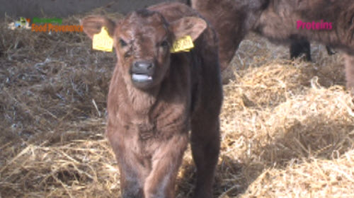
Watch A Beef Cows Spring Video
February – March is when the cows start to have their calves
The farmer will monitor the cows very carefully at this time – another good reason to have them housed as this makes them easier to monitor and help during calving if necessary. And like all the new born calves we saw it was quickly up on its feet and enjoying its first taste of mothers milk. Within a few hours of being born calves must have (Q22) _______________________________________ (Choose from: A wash, a name, ear tags put in ) and be allocated a passport so that this calf can be traced throughout its life. Mr Rook also puts iodine on the calf’s navel this is how it was attached to its mother when in her womb. Until the navel dries and heals the calf could absorb (Q23) _______________________________________(Choose from: milk, water, cold, bacteria) the same as it did food in its mother’s womb. This could lead to infection and even death for the calf. So just to make sure the end of a years work is not lost. Mr Rook also gives the calf an injection of antibiotic to make sure no infection can start. New born calves are on their feet and suckerling within a few minutes of being born. The calf will stop with it's mother for several months....

Year in the Life of a Beef Cow – Late Spring / Summer
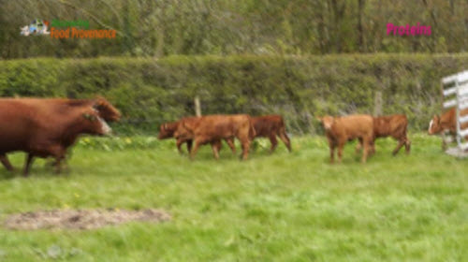
Watch A Beef Cows Summer Video
The cows that calved in February and March are usually turned out to grass later that spring. The farmer is already thinking about next years calves to make sure he improves the cows (Q24) _______________________________________ (Choose from: colour, looks, size, growth )and the taste of their meat he carefully selects the cows for each field. Then he will mate these cows with a specially selected bull to get the type of calves he wants - fast growing and tasty meat!
The cows to go into the first field are being selected here. These 'cowboys' are very experienced but still careful when getting the cows out - they could easily get knocked down and injured. Once the cows have been selected then their calves are identified and also taken out. The cows are loaded on to a special cattle trailer. Before the calves are loaded they are dosed against Coccidiosis a (Q25) _______________________________________ (Choose from: disease, illness bug, parasite ) they can pick up when outside in fields - it gives them diarrhoea and can cause death. The calves are then loaded and taken to the field with their mothers. The cows are very happy to be out in the fields again and run around with joy as well as enjoying their first taste of fresh grass for months. Some calves have a taste too. By the end of the summer as well as drinking milk calves will also be eating lots of grass….
As they are less dependent on their mother’s (Q26) _______________________________________ (Choose from: milk, company, washes, warmth ) they can be weaned. Weaning is when an animal no longer needs its mothers milk and can survive on solid food like grass. This also give the mother a chance to recover as producing milk is very demanding – and she will also have (Q27) _______________________________________ (Choose from: another field of grass to eat, more milk to produce for us, another calf growing in her womb) Calves are usually weaned in their first Autumn and housed inside ready for winter. This completes our year in the life of a beef cow as we are now back round to where we started. We will continue the calf’s story shortly.....

“X” Factor for cows and Billy Bull
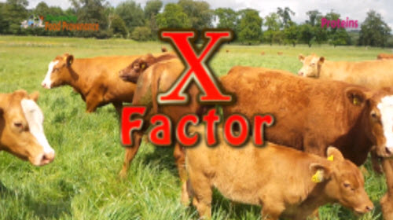
Watch X Factor for Cows Video
We will return to our Beef cows year presently – but first its time for “X Factor” for cows and Billy bull! Each of the beef farmers cows must undergo an “X Factor” like audition. The “X Factor” in this case is selective breeding – only those cows and bulls who have the right traits or characteristics are allowed to (Q28) _______________________________________ (Choose from: eat grass, go on holiday, breed ) Humans have practiced selective breeding ever since we domesticated animals – that is how we got so many breeds of dogs from a wolf....
Today we use modern knowledge of genetics and technology in selective breeding programs.
A beef cow farmers aim is for his suckler cow mothers to have a fit healthy calf each year and for this calf to grow fast and produce lots of tasty (Q29) _______________________________________ (Choose from: milk, food, meat )
Fast growing calves mean the farmer has to (Q30). _______________________________________ (Choose from: feed his calves more food, keep his calves longer, spend less time and money to care for and feed his cattle ride around in his tractor more, )
This is good for the beef farmer as it means he will make more money. But it can also be good for the long term sustainability and security of food production as it will use (Q31) _______________________________________ (Choose from: less time, less space less resources) to produce each beef cow. To ensure a cow has a calf each year the farmer must make sure the cow is mated and becomes pregnant again after she has had her calf.
Cows are pregnant for (Q32) _______________________________________ (Choose from: 7, 8, 9, 10, 11) months the same as humans. So that the cow calves around the same time each year she needs to be mated during the summer when she is out in the fields with this year’s calf. So this means the bull will often be in a field of cows and calves during the summer. As we mentioned earlier a farmer carefully selects cows and bulls for breeding when they are turned out each spring – this is called selective breeding. This selection is done according to certain traits or characteristics of cows and bulls. Just like you not all cows or pigs or sheep for that ,matter are the same..............

“Can Sheep Count?”
Mum Mum MUM - oh yes what number was my mum?
Why do shepherds paint numbers on lambs?
If sheep cannot read, how do they tell which are their lambs from all these - don't they all look the same?
Are all piglets in a litter the same?
What about cattle are they all the same?
Well the numbers are really for the shepherd so he knows which lambs belong to which ewes if they become separated.
Even if we think lambs look the same to the ewes each lamb is very different especially their smell - Oliver explains.....
And in fact although animals of the same type or species look the same to us they are nearly always (Q33) _______________________________________ (Choose from: smelly, bigger, the same slightly different) even if they have the same parents.....
How fast animals grow is one of the traits or characteristics that animals will differ in although not obviously when looking at them. A beef farmer will use growth rate when selecting which cows he will use for breeding – ie the mother suckler cow and the bull she will mate with. So one of the “X Factors” for cows is growth rate ( how much its weight increases in a day) ….
Just like some of your traits such as weight or height this cow “X Factor” is controlled by both (Q34) a _______________________________________ (Choose from: food, temperature, environment, genes, trousers) and the environment
In the case of your height and the cows X Factor growth rate you can have a gene for being tall or growing fast but if the environment does not allow it – eg provide enough of a balanced diet, remain fit and healthy, you will not reach the tallest height or the calf grow as fast as possible. So as we have seen the farmer feeds the cows the best balanced diet he can and keeps them as fit and healthy as possible so the environment does not restrict their growth. As you should know from science - the genes for offspring come from (Q35) _______________________________________ (Choose from: the mother, the father, their siblings, its mother and father) So a beef farmer selectively breeds a breeding cow that has these X Factor genes with a bull that also has X Factor genes. That way the offspring will be more likely to inherit these X Factor genes and make beef production better economically and sustainable. This is where the calf’s ear tag and ID comes in useful as this will allow the farmer to identify and record a calf’s progress as it grows. Then when he comes to select which cows to use for breeding he will know which (Q36) _______________________________________ (Choose from: are old enough to breed, are male, have grown the fastest are female) and make good replacements for new breeding stock.
Similarly when buying a new bull a farmer will be able to check out the growth rate for bulls for sale – bulls are given an score called an (Q37) _______________________________________ (Choose from: Estimated Breeding Value, best of breed score, x factor score ) which gives an indication of the bulls X Factor for growth and tastiness of meat amongst other traits.

a Beef Cow’s summer 2
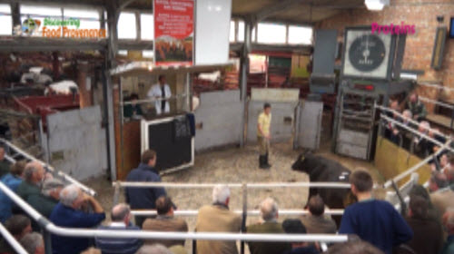
Watch A Beef Cows Summer 2 Video
So now we have looked at the cows “X Factor” lets return to the year in the life of our beef cow...
We left our calf in late summer / early autumn having been weaned from her mother. These calves will be housed over the winter just like the cows we saw being house in an earlier part of our beef story. By turning out time in the spring of their second year some of the oldest calves may now be heavy enough and ready for (Q38) _______________________________________ (Choose from: breeding, slaughter going out into fields, weaning ) If not then they will again be turned out into the fields. To continue growing until they are heavy enough for slaughter. Once they have reached the ideal weight for slaughter then the farmer will sell them. Some farmers take their cattle to a livestock market to be sold. Like here at Malton. The cattle are weighed and put in a ring the auctioneer then takes bids or offers from buyers. The beef animal is sold to the person who offers the most money.Some butchers like Mr Laverack prefer to buy their beef animals straight from the farmer by going to his farm.

The Beef Food Story and sustainability.
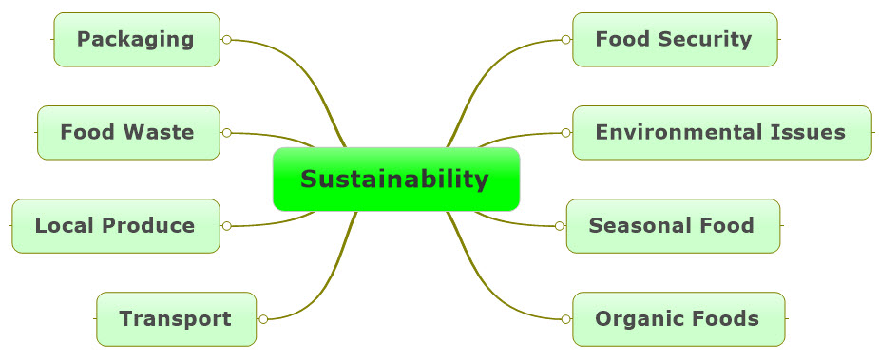
Sustainability can be a difficult idea to grasp – the definition of sustain is to carry on or maintain doing something. So, in terms of food production its simplest definition means can we keep producing food. Well clearly, we can and will keep producing food – but the actual term sustainability is more complex than about just keeping producing food. It basically asks can we keep producing food in the same ways that we are doing at the moment, for the next 10, 20, 100 years? This then brings in the issues shown above. This then becomes a more complex problem and the answers are not always clear depending on who you ask, their point of view and indeed your own point of view, such as does the environment matter?
Each of the food stories of the Eat Well Guide:
- Cereals
- Beef
- Dairy
- Fresh Produce
covers a different aspect of sustainability. So, once you have completed them all you should have a better understanding of the issues around sustainability.

The Beef Food Story and Sustainability.
The beef food story has links to several environmental issues. Livestock farming (keeping animals) is often referred to as ‘intensive’ or ‘factory’ farming. These methods have evolved to allow farmers to produce as much food as cheaply as possible to feed a growing UK and world population. It is up to the consumer to decide if they can afford to pay more for food produced under less intensive methods such as the “RSPCA Freedom foods” which stipulates less ‘intense’ methods.
That said much of the beef produced in the UK is not produced as intensively as in some countries. UK beef invariably spends much of its life in the fields eating grass, some all year round. So coupled with the selective breeding to produce faster growing tastier meat UK beef is striving to be more and more sustainable, by using land unsuitable for crops and producing more meat in a shorter time from each animal requiring fewer resources per joint of beef!
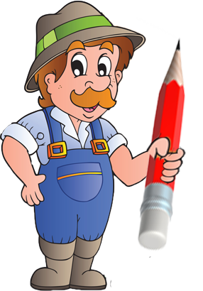
Using the key words or phrases (each word or phrase is separated by a comma (,) ) in the box to explain in your own words how beef farmers are working to produce food and at the same time protect the environment.

Selective breeding, food security, calf’s ear tag id, British beef cattle, growth rate, balanced diet, grass fields, replacement cows, unsuitable for crops, Estimated Breeding Value, heifer, tastiness of meat, less resources, sustainable

You could start with…
Beef farmers practice selective breeding to …

