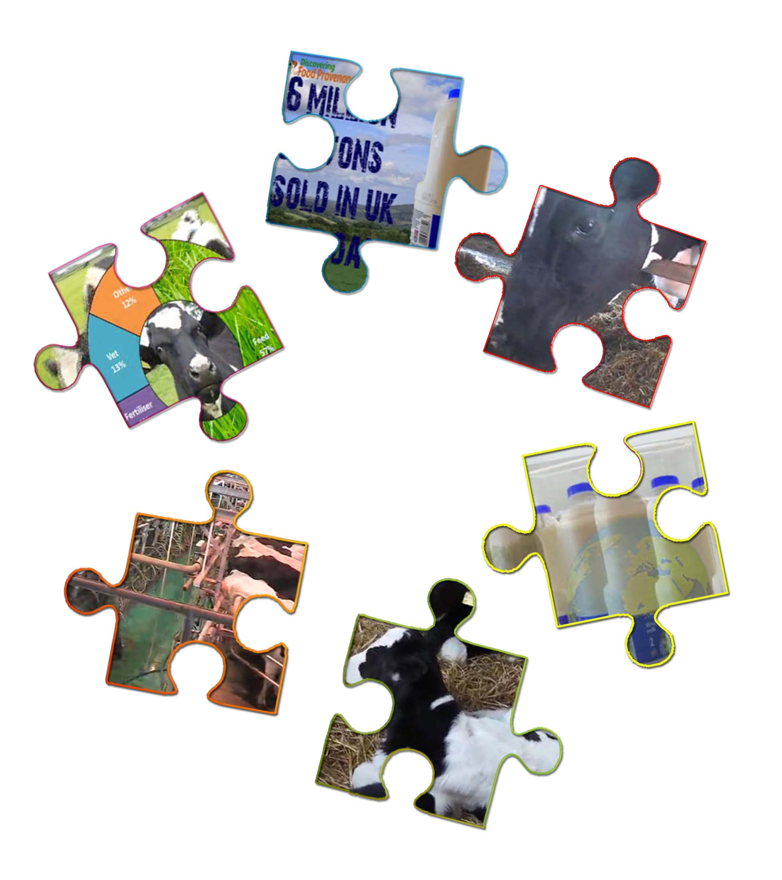
Piecing together....
The dairy and alternatives food story.

Milk Food Story

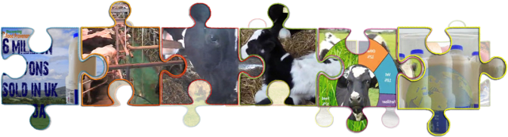
Your Name
GCSE Food Preparation & Nutrition
Teacher’s Name

Food provenance – Milk food story
Today’s Learning
- Describe the stages of the milk food story.
- Describe what selective breeding is.
- Explain how farmers use selective breeding to produce milk more efficiently.
- Explain how artificial insemination and sexed semen are used to produce milk and beef more sustainably.
Your task is to watch the videos at:
http://discovering-our-countryside.co.uk/milkfoodstory/
Then answer the questions for each video

The White Stuff! - milk Introduction
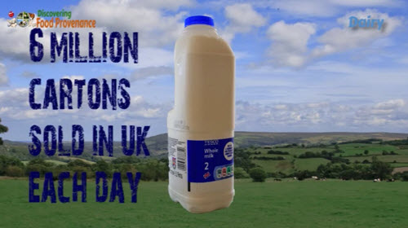
Watch Milk Intro Video
The White Stuff.
6 million of these are sold in the UK each day – some of it drunk by you. That's enough milk to fill (Q1) _________________________( Choose from: 41, 14, 4, 401) swimming pools. But do you know how Milk is produced and gets into these cartons?
This Food Story shows the Eat Well Harvest of Milk
Milk belongs to the dairy and alternatives Eat Well Guide Food Group and includes fresh milk, cream, cheese, yoghurt and fromage frais.
Milk and dairy products are a good source of (Q2) _________________________( Choose from: protein fat carbohydrate ) and vitamins…..
They are also an important source of calcium which helps to keep your (Q3) _________________________( Choose from: legs, muscles, bones, arms ) bones strong. Milk has also been proven to be a great (Q4) _________________________( Choose from: re-hydrating, refreshing, sweet, cheap ) drink for athletes better than other sports aid drinks sold for this….
Milk usually comes from cows. Cows which produce milk are usually black and white and called Dairy Cows. Milk can also come from (Q5) _________________________( Choose from: pigs, dogs, llamas, sheep ) and goats in this country.
Farmers have selectively breed dairy cows for producing milk. Dairy cows are still the same species as beef cows, they are still ruminants which means they have 4 stomachs. But instead of meat they have been selected for producing (Q6) _________________________( Choose from: pork, milk, butter, ice cream ). They have much bigger udders than beef cows and produce more milk per day than beef cows – up to (Q7) _________________________( Choose from: 50, 60, 70, 80) litres per day compared to a beef cows 15 litres
Dairy cows can still be used for meat – they just don’t produce as much on each animal or grow to slaughter weight as quickly so are less (Q8) _________________________( Choose from: fun, use, profitable, easy ) for a farmer to keep for meat. The other difference between a dairy cow herd and a beef cow herd is that dairy cows don’t tend to calf all at the same time of year. To even out the flow of milk produced by a dairy farm and available for you in the shops, the dairy farmer will usually have cows calving all year round
So let’s follow a dairy cows day.....

Milking – Early start for cow and farmer.
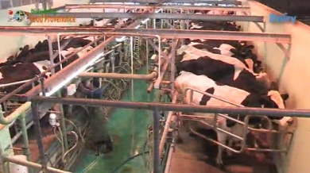
Watch Milking Early Start video
A dairy cows day and dairy farmers day starts around (Q9) _________________________( Choose from: 5pm, 4am, 5am, 6am, 7am ) with milking
Dairy Cows soon get to know the daily routine and will enter the parlour with little prompting keen to release their milk.
Some milking parlours are like a (Q10) _________________________( Choose from: barn, roundabout, helter-skelter, computer game ) like this one where goats are being milked.
When cows first enter the milking parlour the farmer cleans their udders.
Milking does not hurt the cows, in fact cows are happy to be milked as they can get rid of the weight of milk in their udders - could you carry these around all day?
Some cows even start to release milk before the farmer has put the milking machine on. Once the udders are clean the farmer then continues with the milking process. This is called the (Q11) _________________________( Choose from: sucker, washer, milking cluster, milking parlour ) – it is put on the animals udder and gently squeezes the milk out. The milk produced by each animal is carefully measured and recorded by a (Q12) _________________________( Choose from: secretary, piece of paper, computer, tape recorder ). Once the milk has been squeezed out the cluster releases automatically. The milk goes into a special (Q13) _________________________( Choose from: big, silver, cooling, milk ) tank where it will be stored until it is picked up by a tanker lorry

Rest of the day
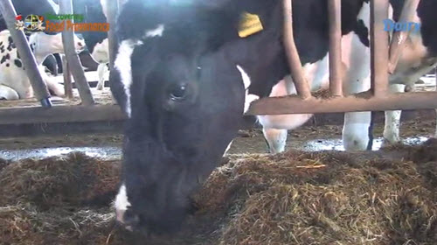
Watch Rest of the day video
Once milked the dairy cows day then depends on the time of year. Most of the year dairy cows spend their time (Q14) _________________________( Choose from: sleeping, running around, laying down, out in the fields ) only going inside each day for milking. So from early spring to late autumn cows return back to their field after the morning milking to eat grass and make more milk.
From late autumn and over winter dairy cows will spend the day (Q15) _________________________( Choose from: getting wet, in muddy fields, cold, inside in warm dry barns). This is better for the cows – the grass does not grow over the winter so would not provide enough food for them! It is also better for the grass as it stops it from becoming very muddy damaged or even killed...
When inside they will eat grass that has been harvested over the summer and preserved specially to feed them over the winter.
The preserved grass the farmer uses in these rations is called silage
The farm made this silage in the summer from fields of grass which he did not allow the cows to eat
First the grass is cut
The cut grass is left a day to dry or wilt, before being collected and squashed into a bale of grass by a machine called a (Q16) _________________________( Choose from: tractor, combine harvester, trailer, baler).
The bale of grass is then picked up and wrapped in plastic like cling film
Wrapping keeps the air out and pickles or preserves the grass as (Q17) _________________________( Choose from: hay, straw, manure, silage ).
Bales of silage can be square or round.
Pickled grass just how cows like it….
The dairy farmer / stockman after early morning milking then spends the rest of the day doing other stockman jobs, bedding up, feeding, and generally checking and tending his livestock.
Until milking time again.....

Where does calving fit in?
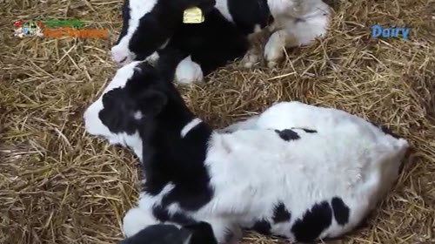
Watch Where does calving fit in video

Where does calving fit in?
So our dairy cows get milked twice everyday – but does calving fit in?
The cow…. What sort of animal is it?
Is it a bird?
Is it a fish?
Is it an amphibian?
Is it a reptile?
Is it an invertebrate?
Is it a mammal?
Which are you?
Well these are all animals. Each group has certain characteristics – birds lay eggs
You and the cow are in the same group – (Q18) _________________________( Choose from: birds, fish, reptiles, mammals).
What is special about mammals?
Mammals produce milk – for their young which means they must first have to have young before they produce the milk.
So dairy cows must have a (Q19) _________________________( Choose from: holiday, dance, calf, birthday ) each year in order to produce milk for us to collect and use.
A dairy cows (Q20) _________________________( Choose from: age, size, milk yield, food) (amount of milk produced) increases gradually after she has given birth originally to suit her calf’s need as it grows. Eventually in nature the calf (like you did when you where little) would start eating solids in the cows case grass.
The offspring would eventually be (Q21) _________________________( Choose from: old, moved, fed, weaned) – and would stop drinking milk, so the mother would stop making it! This pattern still happens with a dairy cow - the amount of milk being produced each day eventually drops to an amount that is not economic for the farmer.
To overcome this the farmer makes sure that the dairy cow has a calf each year.
So the dairy cow will be mated and become pregnant again whilst she is still being milked.
The farmer will record this mating so he knows when the cow is due to have her next calf. (Q22) _________________________( Choose from: 1-2, 3-4, 4-5, 6-7, 8-9) weeks before this she will stop being milked. This is called drying off and means because she has stopped being milked she will stop producing milk – she will be dry! This is just like what would happen in the wild when the calf is weaned. The dairy farmer does this to allow the cow a short time to recover before she has her next calf.
The farmer will monitor the cow very closely when calving is imminent – assisting as necessary...
New born calves are on their feet and suckerling within a few minutes of being born. If we want the cows milk we must wean the calf as Peter Burdass a dairy farmer explains.....

Feeding – feeding dairy cows
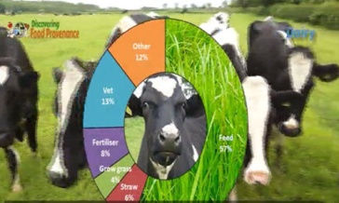
Watch Feeding Dairy Cows Video
Today’s dairy farming serves to illustrates the (Q23) _________________________( Choose from: size, amount, globalisation, price) of our food production largely controlled by large food processors and super markets.
This change has happened gradually over the last generation or so of dairy farmers. Not so long ago each small area / village had their own local dairy farm which (Q24) _________________________( Choose from: made a smell, kept cows, delivered milk daily to their doorstep). On the whole these have all gone to the extent that milk is now traded and transported around the world in a similar time to which it was delivered to local a doorstep. Dairy farmers have had to adapt and become more efficient to survive in this global market of large multi-national dairies and super markets. Today’s dairy farmer must now produce milk within a price dictated by these large companies who form the market for the majority of the milk produced. The price per litre a farmer is given for his milk is (Q25) _________________________ ( Choose from: great, very high, just right, often less than what it costs him to produce a litre of milk) he sells!!! In fact the price he gets for milk is often less than the price he pays for the water the cows drink! This has generally meant the end of the small family dairy farm as the only way dairy farmers could survive has to become more efficient.
Becoming efficient has meant each farmer must keep more cows and get as much (Q26) _________________________ ( Choose from: yield, food, cream, meat) from each cow. Doing this means the farmer is able to spread their costs over more litres of milk produce – it is called an economy of scale.
How much milk a cow produces is controlled by the cows (Q27) _________________________ (Choose from: colour and size, genes and environment, genes and shirt, environment and age)– how well it is looked after and how well it is fed.
One of the main costs of keeping dairy cows is the (Q28) _________________________ (Choose from: vets bills, feed, bedding, fertiliser ). So feeding a dairy cow the right amount of a balanced diet to achieve the maximum yield of milk but with as cheap as price as possible is now very important to dairy farmers.
With dairy cows producing as much as 60 litres of milk per day they cannot get enough (Q29) _________________________( Choose from: water, nutrients, milk, fats) from just eating grass. So they will also be fed extra food called concentrates – this is a mixture of other foods such as soya beans, rapeseed meal wheat. This extra food is fed according to what each cow needs – which is worked out by recording how much milk they produce each day. As Mr Burdass explains….
A computer then works this out and feeds the cow THIS EXTRA FOOD accordingly when it goes into the parlour to be milked or in special feed stations. The computer identifies each cow by (Q30) _________________________( Choose from: its name, its colour, asking it, a special transponder ) a . So each cow gets just the right amount of the balanced diet it needs. Just one example of how technology is used to feed dairy cows making dairy farming more efficient and sustainable.

Breeding – Dairy Cows X Factor!
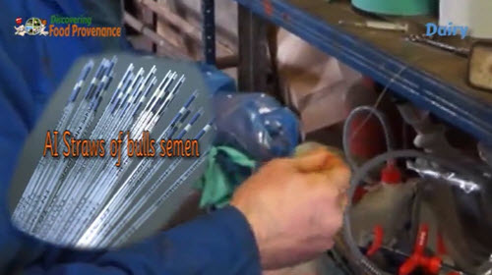
Watch Dairy Cows X Factor Video
Breeding is an important part of dairy farming.
Not only must a cow have a calf each year it is also how dairy farmers can increase the milk yield of their cows.
But as we have said in order to be efficient a dairy farmer must try and produce as big a yield of milk as possible from each cow. A cows milk yield is controlled by the cows environment and the cows breeding or genes.
Each year a dairy farmer will need to (Q31) _________________________( Choose from: sell, send on holiday, calve, replace) some of his dairy cows as some become too old to milk or infertile and cannot have another calf. A dairy farmer will practice selective breeding to get these replacement cows. Dairy farmers just like beef farmers have “X Factor” like auditions to decide which of their dairy cows and bulls they will use to breed replacements from. One of the main “X Factors” in the case of dairy cows is quality and yield of milk produced.
Humans have practiced selective breeding ever since we domesticated animals – that is how we got so many breeds of dogs from a wolf. Today we use modern knowledge of genetics and technology in selective breeding programs. Technology allows dairy farmers to record the milk yield of all his cows. He will use these records to select the cows to breed replacements from. These best cows will be mated to a (Q32) _________________________( Choose from: beef, white, young, dairy) bull.
Dairy bulls obviously don’t produce a milk yield but the effect of their genes on milk yield is worked out from the milk yield of their mothers, siblings and female offspring. The results are published in books like this..... each of these bulls are worth thousands of pounds. These results can be used to select the best bulls to mate with a dairy farmers best milking cows. Each of the farmer’s selected cows could be matched and mated to a different bull to get the improvement not only in milk yield but also other traits such as milk fat or protein. The use of (Q33) _________________________( Choose from: artificial intelligence, beef bulls, artificial insemination, dairy bulls ) (AI) allows a dairy farmer to do this as he could not afford to have lots of different bulls on his farm. This is how the cow is AI’d .....
As we said to produce milk a cow must have a calf each year – so all the dairy farmers cows must have calves. But a dairy farmer will only replace a small proportion of his milking cows each year which means he will only need a small proportion of all the female calves for replacements. All the bull calves and the rest of the female calves can be reared for beef, although calves breed from a dairy cow and dairy bull will not produce a beef animal very economically as they don’t grow as fast as pure beef breed calves. So for this reason a dairy farmer will only mate his best dairy cows with a dairy bull – the rest he will mate with a beef bull. This will make the calves (Q34) _________________________( Choose from: big, a different colour, half beef breed, half dairy breed ) and they will be more economic to rear for beef compared with a pure dairy calf. These calves are often sold to other farmers to rear for beef. This is reflected in the value of calves which a dairy farmer does not want for replacements and are reared for beef. A pure dairy calf like this is only worth £40-50 compared to this calf which is from a dairy cow and this Simmental Beef Bull which is worth £200
The dairy farmer will have to mate twice as many dairy cows to dairy bulls that he needs to get his replacement cows. This is obviously because normally the calves from the pure dairy bull will be half female and half male this still means the farmer will end up with some pure dairy bulls to rear for beef which is not economic. With modern technology the semen can now be (Q35) _________________________( Choose from: frozen, sexed, washed, stored) so that it only produces female calves! So the dairy farmer can now just mate the number of cows he needs for replacements with a dairy bull. The rest of the herd can all be mated with beef bulls – producing more half beef calves.
Selective breeding, using AI and sexed semen is good for the long term sustainability and security of food production as it will use less resources to produce each litre of milk. And produce beef more efficiently by allowing more cows to be mated with a beef bull rather than a less beef efficient dairy bull!

Processing Milk
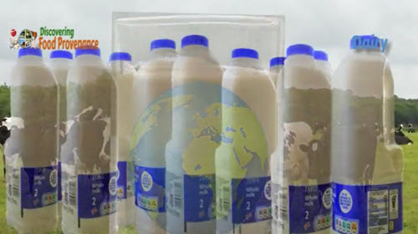
Watch Processing Milk Video
The White Stuff.
6 million of these are sold in the UK each day – some of it drunk by you. That's enough milk to fill swimming pools. But do you know how Milk is produced and gets into these cartons?
Go tell ‘em. Milks great for athletes you know. Are you one? We saw how cows are milked.
Here we are going to see the milk processed into cream and bottled to drink.
The liquid milk must first be heated to kill any bugs – this is called (Q36) _________________________( Choose from: pasteurisation, evaporated, photosynthesised, boiled ).
To extract the cream from the milk it is spun at high speed in this machine a bit like a washing machine.
James is using his skill to get the cream just the right thickness to make: single, double or whipping cream.
Once he is happy then he puts it into pots.
Seals it and adds a use by date .
The milk which has had the cream extracted then goes to make skimmed or semi-skimmed milk.
Whole milk is made from milk which has had no cream removed.
Here’s the milk being pumped into cartons.
Lids put on
The lids are colour coded depending on f the milk is: whole milk, semi-skimmed or skimmed milk.
Labelled Ready to drink
So why is milk good for athletes after exercise?
Exercising causes the body to lose not only fluids but also vitamins and minerals.
So after exercise you need to drink to replace not only these fluids but the (Q37) _________________________( Choose from: fluids, water, sweat, vitamins & minerals ) too.
Peter Burdass explains more….

Using the key words in the box to explain in your own words how farmers are working to produce food and at the same time protect the environment.
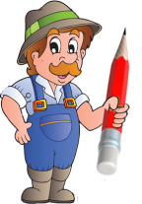
selectively breed, price per litre, yield, computer, transponder, highest yielding cows, artificial insemination, different dairy bulls, sexed semen, beef-cross calves, highest yielding cows, sustainable

You could start with…
Dairy farmers....

