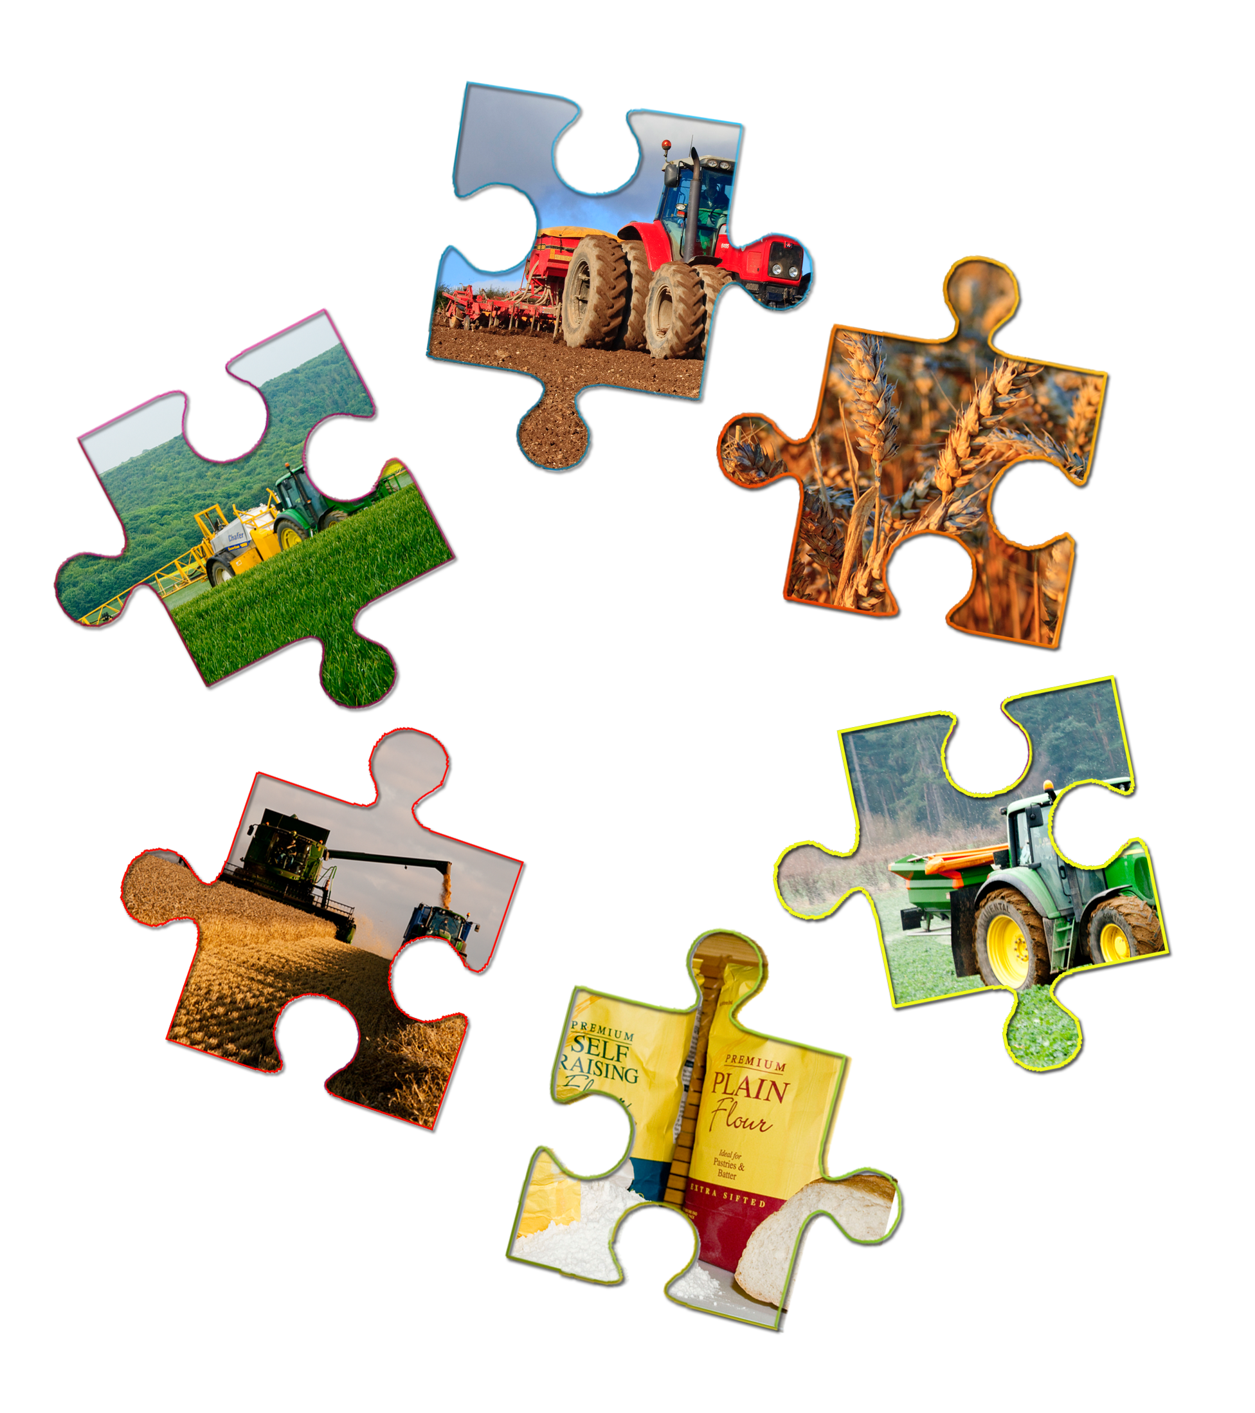

Piecing together....

The starchy carbohydrate food story.

**Cereal Food Story**

Your Name

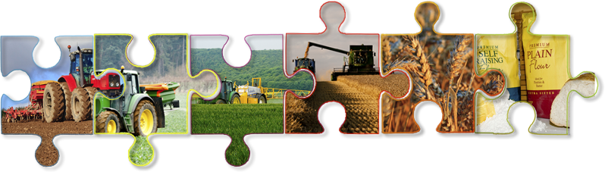GCSE Food Preparation & Nutrition

Teacher’s Name

# Food provenance – cereals food story

Today’s Learning

* *Describe the stages of the cereal food story.*
* *Describe what precision farming is.*
* *Explain how farmers use precision farming to protect the environment.*
* *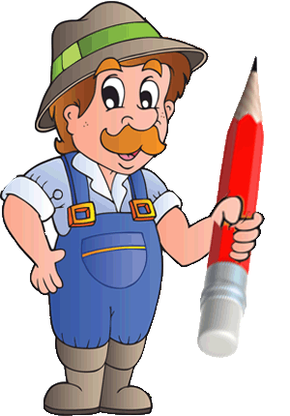Explain how protecting the environment makes cereal production sustainable.*

Your task is to watch the videos at:

<http://discovering-our-countryside.co.uk/cerealfoodstory/>

Then answer the questions for each video

Read the important instructions for saving this Food Story Workbook – towards the end of this document to prevent losing your work – read now

### Cereals Introduction

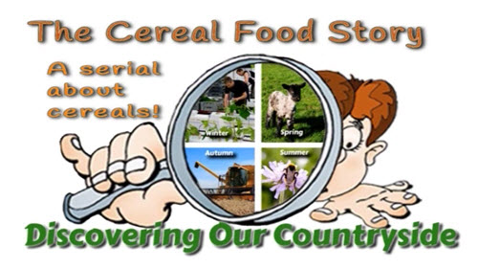 *Watch Cereals Intro Video*

Cereals belong to the potatoes, bread, rice, pasta ‘Eat Well Guide’ food group. They are a ***(Q1)*** _______________________________________  
**(Choose from:** “good way to make beer" "good source starchy food " "good to watch on TV" "good crop to harvest in summer"**)** which should make up just over a third of the food you eat.

***(Q2)*** List the 3 main types of cereals grown in this country _______________________________________**(Choose from:** “Barley, Maize, Oats, Rice, Rye, Wheat)

### Preparing the land

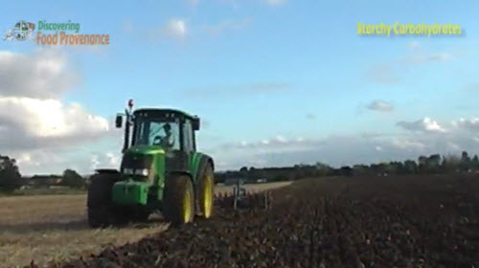 *Watch Preparing Land Video*

Winter cereals are sown in the ***(Q3)*** _______________________________________**(Choose from: “** Winter, Summer, Autumn**)** and harvested the following summer. Spring cereals are sown in the spring and harvested the ***(Q4)*** _______________________________________ **(Choose from: “**previous, same, 2 years time) summer.

When cereal seed comes into contact with soil it takes up moisture and ***(Q5)*** _______________________________________**(Choose from: “** photosynthesises, germinates, pollinates, fertilises )

Ploughing is part of the farmers integrated pest and disease management. Ploughing buries any residues of the previous crop which may harbour ***(Q6)*** _______________________________________ **(Choose from**: “ dead leaves, pests and disease, worms, bees ) that could infect the new crop.

Sometimes a farmer may use a different machine to prepare the seedbed and sow the cereals in one pass of the tractor. This is good for the farmer as ***(Q7)*** _______________________________________ **(Choose from**: “ gives job variety, saves fuel, stops farmer relying on one machine) it is also good for the environment as it ***(Q8)*** _______________________________________ **(Choose from**: “ makes less noise, produces less pollution, is kinder to worms )

### Sowing the seed

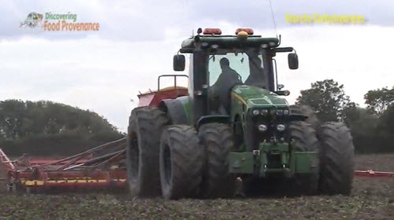 *Watch Sowing the seed Video*

Farmers use a machine called a ***(Q9***_______________________________________ **(Choose from**: “ Tractor, Combine Harvester, Seed Drill, Plough) to sow seeds with. The amount of seed sown is controlled by   
***(Q10)*** _______________________________________ **(Choose from**: “the speed the tractor is going, the size of the seed, a computer in the tractor cab)

Precision Agriculture means ***(Q11)*** _______________________________________ **(Choose from**: “ being careful when driving a tractor, getting more for less, using a computer)

Precision Agriculture is good for the farmer because it ***(Q12)*** _______________________________________ **(Choose from**: “ prevents accidents, saves money, means he has lots of toys ) it is also good for the environment because   
***(Q13)*** _______________________________________ **(Choose from**: “ uses less resources, saves money, scares less wildlife)

### Caring for cereal crops – Crop Husbandry

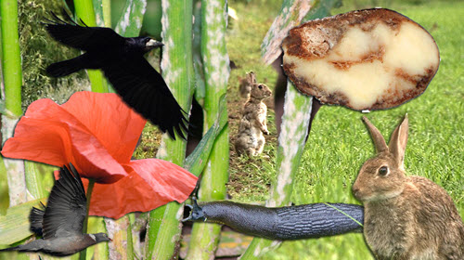 *Watch Crop Care Video*

Once the farmer has planted his cereal crop he must look after it until it is ready to harvest – for a crop sown in the Autumn (called winter cereals) this can be for 10-11 months until the following summer when they are harvested.

A cereal farmers goal is to grow lots of ***(Q14)*** _______________________________________ **(Choose from**: “ pretty flowers, weeds, crops, healthy plants)

Such plants have leaves that are able to capture as much light as possible for photosynthesise allowing them to make as much   
***(Q15***_______________________________________ **(Choose from**: “ protein, fats, glucose, lipids) as they can.

***(Q16)*** The plants then use this glucose with other nutrients such as - *select the 3 main nutrients plants need* _______________________________________ **(Choose from**: “Carbon, Hydrogen, Nitrogen, Oxygen, Phosphate, Potash )

### Providing crop with extra nutrients

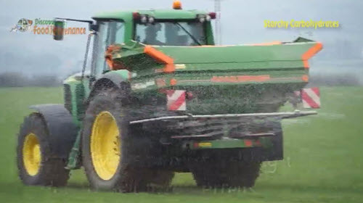 *Watch Applying Fertiliser Video*

Farmers will test the soil in a field for ***(Q17)*** _______________________________________ **(Choose from**: “ worms, stones, nutrients, treasure.)

He will then use this information to create a ***(Q18)*** _______________________________________ **(Choose from**: “ nutrient map, map of his land, graph of number of worms, yield map.)

This map is then used to work out how much extra nutrients each area of the field needs.

Farmers apply any extra Nitrogen, Phosphate or Potash the crops need either in the form of farm yard manure or artificial fertilizer.

The fertiliser is applied with a fertiliser spreader that is controlled by a ***(Q19)*** _______________________________________ **(Choose from**: “ computer, lever, farmer) in the tractor cab

This means that the fertiliser can be applied ***(Q20)*** _______________________________________ **(Choose from**: “ with precision, by guessing, by looking out of the tractor window) just as required in each part of the field according to the field nutrient map.

***(Q21)*** The benefits of applying fertiliser in this way are _______________________________________ **(Choose from**:

1. The farmer has a computer to play games on in his tractor
2. Less fertiliser is used saving the farmer money
3. The farmer
4. The fertiliser is applied accurately according to the field nutrient map
5. Fertiliser is applied in a way that is safe for the environment

You can be sure you are buying food produced under farm assurance schemes rules by looking for the ***(Q22)*** _______________________________________ **(Choose from**: “ British Union Jack, Red Tractor, picture of a farm, ) on the food packaging.

### Protecting plants from attack

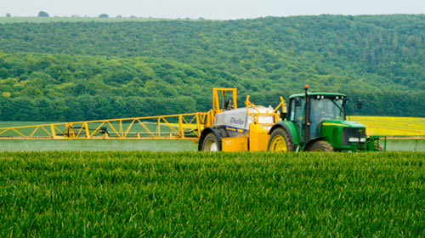 *Watch Pests & Disease Video*

To get healthy plants a cereal farmer must protect his plants from

***(Q23)*** _______________________________________ **(Choose from**: “ the sun, pests and disease, all wildlife, ) especially the leaves so that they photosynthesise at the maximum rate.

***(Q24)*** Pests and disease are bad because they can _______________________________________ **(Choose from**: damage the crops leaves reducing crop yield

contaminate the crop with their seeds

make the countryside look untidy

provide food for wildlife

Farmers will try to control pests and disease by using ***(Q25)*** _______________________________________ **(Choose from**: “ a special, the maximum, an integrated, the cheapest ) approach which involves a combination of methods: crop rotation, cultivations plus chemicals

***(Q26)*** What do farmers do to make sure they can control pests and disease as safely as possible: _______________________________________ **(Choose from**:

*Take a test to make sure they use chemicals safely*

*Use a computer to apply chemicals with precision*

*Use an integrated approach*

*Use a flashing light when spraying crops*

*Chase all wildlife out of the field first*

### Harvesting the Crop

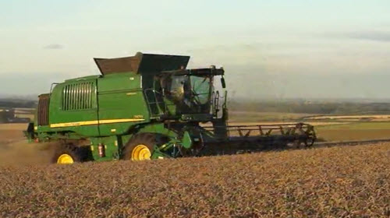 *Watch Harvesting Cereals Video*

Cereals are harvested by a machine called a using ***(Q27)* (Choose from**: “Tractor, Combine Harvester, Seed Drill, Plough) They record the amount of crop harvested (yield) as they work.

Coupled with a Global Positioning system they can create ***(Q28)*** _______________________________________ **(Choose from**: “ yield nutrient map, map of his land, graph of number of worms, yield map ) for each field.

The farmer can then link this yield map with the field nutrient map he used to apply fertiliser this allows him to  
 ***(Q29)*** _______________________________________ **(Choose from**: check if his fertiliser plan was successful, see if the field has any weeds in, see if pests have done any damage)

### Uses of Cereals.

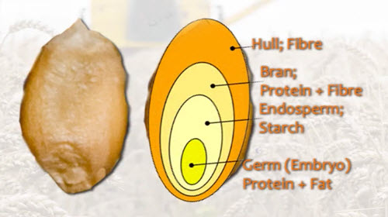 *Watch Use of cereals Video*

All cereal grains are similar to each other in structure.

Wheat is one of main cereals grown around world so forms a valuable part of the ***(Q30)*** _______________________________________ **(Choose from**: “ protein, 5 A Day, fat, carbohydrates) in our diet.

***(Q31)*** Cereals can be used for making _______________________________________ **(Choose from**: Beer, Malt, Flour, Animal Feed, Pasta, Flavouring in many products, Fuel – ethanol)

### The Cereal Food Story and sustainability.

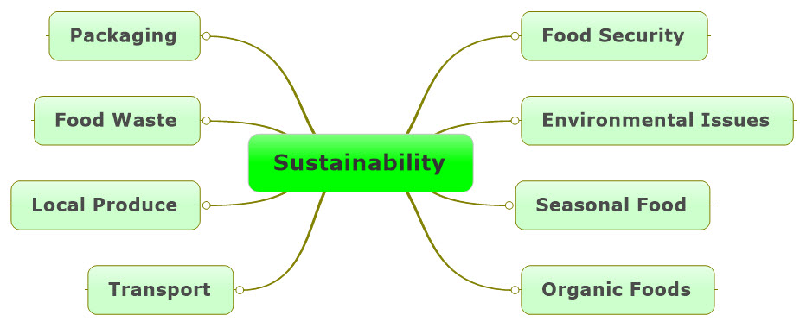

Sustainability can be a difficult idea to grasp – the definition of sustain is to carry on or maintain doing something. So, in terms of food production its simplest definition means can we keep producing food. Well clearly, we can and will keep producing food – but the actual term sustainability is more complex than about just keeping producing food. It basically asks can we keep producing food in the same ways that we are doing at the moment, for the next 10, 20, 100 years? This then brings in the issues shown above. This then becomes a more complex problem and the answers are not always clear depending on who you ask, their point of view and indeed your own point of view, such as does the environment matter?

Each of the food stories of the Eat Well Guide:

* Cereals
* Beef
* Dairy
* Fresh Produce

covers a different aspect of sustainability. So, once you have completed them all you should have a better understanding of the issues around sustainability.

#### The Cereals Food Story and Sustainability.

The cereal food story has links to several environmental issues.

Growing cereals using artificial fertilisers and chemical sprays is often referred to as ‘Intensive Farming’ – some people think using large amounts of fertiliser and sprays is bad for us and the environment as the fertiliser and sprays can contaminate water in rivers and dykes. Sprays can also kill insects and other wildlife which are not pests and are actually helpful to the farmer such as bees and ladybirds.

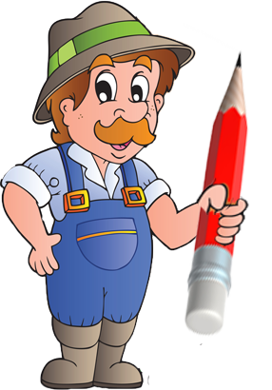The sprays and fertilisers are also made from oil or use fossil fuels in their production so may not be sustainable in the long term. Cereal farmers and the agricultural industry are well aware of these issues and arguments against their methods of production and are doing what they can to deal with these – and at the same time trying to ensure they produce as much food as the population needs.

*Using the key words in the box to explain in your own words how farmers are working to produce food and at the same time protect the environment.*

**Integrated, precision agriculture, pests and disease, yield maps, field nutrient maps, Global Positioning System, computer control, yield, protect environment, crop rotations, get more from less, chemical sprays, cultivations**

*You could start with…*

*Cereal farmers grow cereals such as wheat barley and oats. They aim to ….*