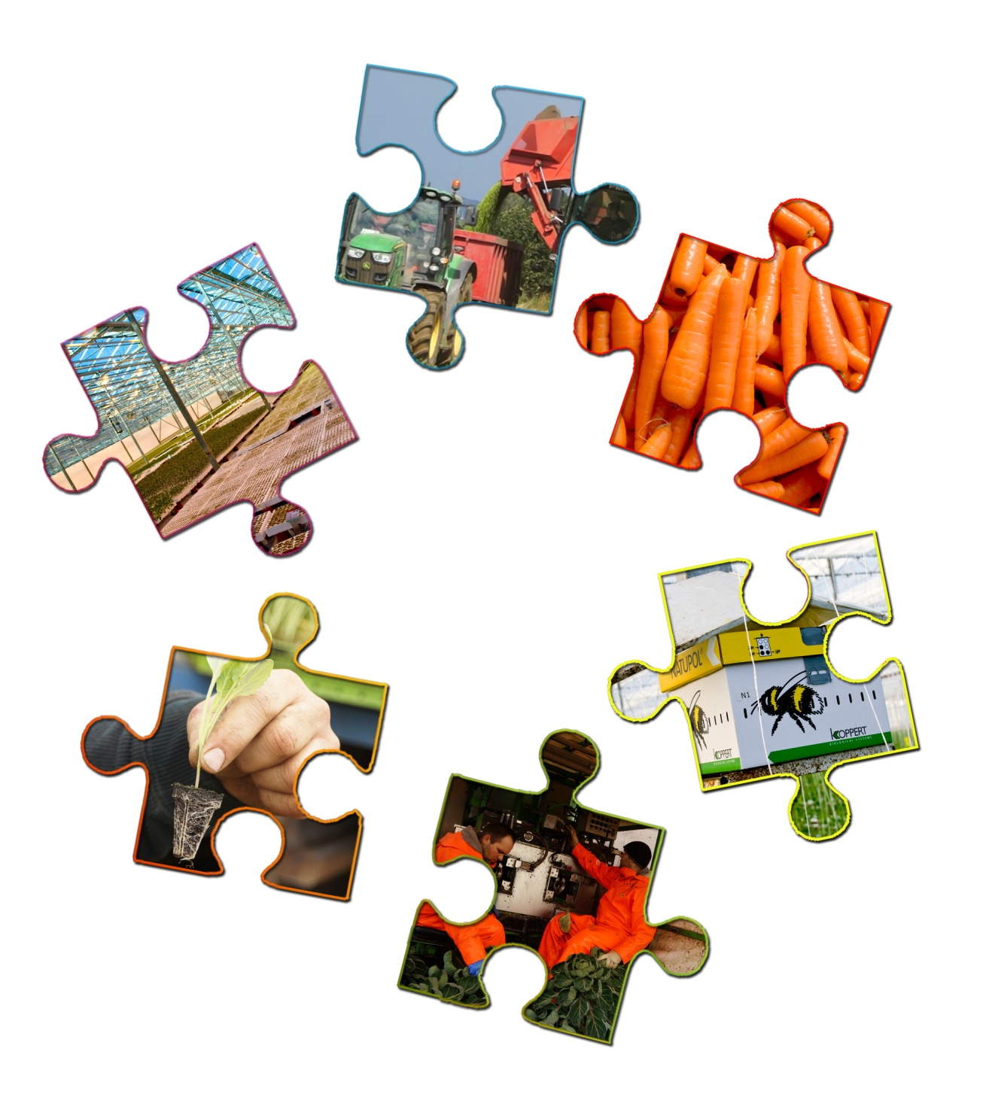

Piecing together....

The fruit and vegetables food story.

**Fresh Produce Food Story**

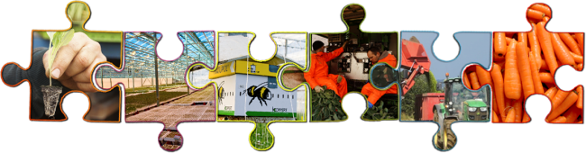Your Name

GCSE Food Preparation & Nutrition

Teacher’s Name

# Food provenance – fresh produce food story

Today’s Learning

* *Describe the stages of the fresh produce food story.*
* *Describe what biological control is.*
* *Explain how growing fresh produce in a glass house can be carbon neutral .*
* 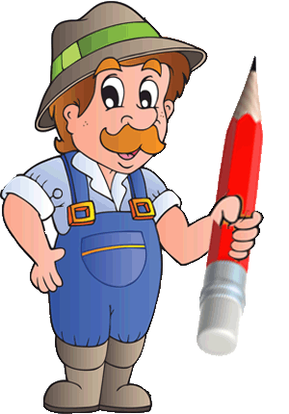*Explain how eating traditionally “seasonal” produce all year round can have an impact on the environment.*

Your task is to watch the videos at:

<http://discovering-our-countryside.co.uk/fruitvegfoodstory/>

Then answer the questions for each video

### FRESH PRODUCE - Intro

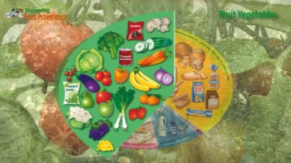 *Watch Fresh Produce Intro Video*

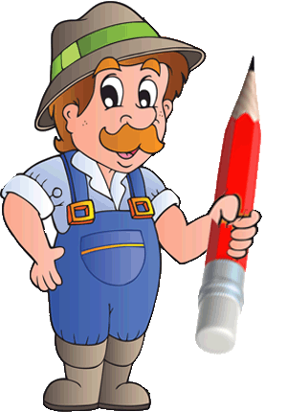A healthy diet should contain Fruit and veg

These should make up just over a ***(Q1)*** **_________________________**( **Choose from:** half, third, quarter) **third** of the food we eat each day. You should aim to eat at least five portions of a variety of fruit and veg each day.

This Food Story shows the **Eat Well Harvest** of some seasonal vegetables that are produced in this country. Carrots, Peas, Beetroot, Brussels Sprouts Tomatoes.....

Vegetables come from all the different parts of the ***(Q2)*** **_________________________**( **Choose from:** world, ground, farm, plant).

Vegetables are best eaten seasonally! As plants grow through their life cycle the part we eat becomes ripe. This happens at different ***(Q3)*** **_________________________**( **Choose from:** times, weeks, months seasons) of the year depending on the plant.

Plants eaten at this stage are freshest, better quality and provide the best ***(Q4)*** **_________________________**( **Choose from:** taste, smell, colour, nutritional value )

They are also often ***(Q5)*** **_________________________**( **Choose from:** biggest, smallest, expensive, cheapest) at this time as so many are available.

We can use ***(Q6)*** **_________________________**( **Choose from:** sun, land, lights, technology) to help extend a plants season so that we can eat traditionally “Seasonal Foods” all year round.

Understanding how we grow different vegetables in this country may help you to decide if it is good or bad to be able to have this wide choice of foods all year round.

### Growing Veg

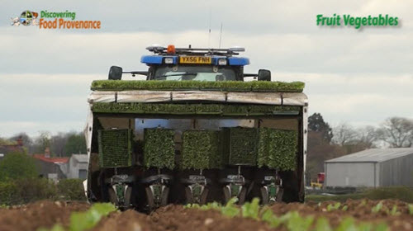 *Watch Growing Fresh Produce Video*

Some vegetables are grown in ***(Q7)*** **_________________________**( **Choose from:** gardens, window boxes, allotments , fields) and some are grown in Glass Houses.

Of the field grown vegetables some are planted or sown as seeds

Carrots, Peas, and beetroot are sown as seed.

Peas are sown in the same way as cereals often with the same machine

Carrots, Parsnips and Beetroot are sown in ‘beds’

“Beds” of beetroot plants. "Beds" are just a - ***(Q8)*** **_________________________**( **Choose from:** place to sleep, lot of plants, set number of rows ) grouped together so the harvesting machine can harvest a bed all at once.

Vegetables such as cabbages, Brussels Sprouts, Leeks lettuce are planted as seeds and grown in Glass Houses until they are small plants. These are then planted out into fields.

Sometimes the newly sown seed and plants maybe covered with a ***(Q9)*** **_________________________**( **Choose from:** soil, rain, straw, special fleece or plastic.)

This is to protect them from ***(Q10)*** **_________________________**( **Choose from:** rain, pest, sun, early frost) and means the crop will be ripe earlier so giving a longer ‘season’ for the crop – and you more choice in the shops!

Vegetables grown in glasshouses maybe grown by specialist growers who grow the plants from seed.

The plants are grown to a certain size and then sent to ***(Q11)*** **_________________________**( **Choose from:**  shops, the tip, a garden, ‘commercial’ Glass Houses )where they are matured and cropped.

Like these tomato and cucumbers...

Or the plants may be started as seeds and cropped in the same greenhouse like these living salads.

### Caring for Veg

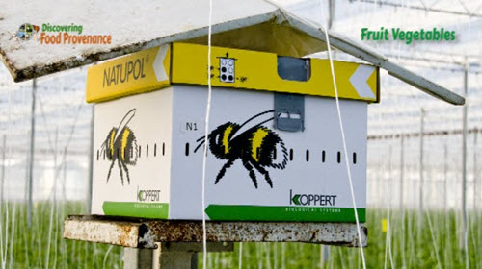 *Watch caring for Fresh Produce Video*

All crops grown must be cared for after they have been planted....

This includes protecting them from ***(Q12)*** **_________________________**( **Choose from:**  harm, sun, the weather, pests)

For the crops grown in the field this is done in a similar way to cereals

The farmer will use an ***(Q13)*** **_________________________**( **Choose from:** carefree, expensive, haphazard, integrated approach ) which may include using pesticide sprays.

Sometimes sprays have to be used to provide perfect veg in the shop – when ***(Q14)*** **_________________________**( **Choose from:** bright orange, very straight, clean, ‘ugly’ mucky) carrots and parsnips have the same nutritional value and are perfectly safe!

Crops grown in glasshouses can also be attacked by pests and disease – sometimes the farmer – actually a ***(Q15)*** **_________________________**( **Choose from:** sunbather, livestock farmer, arable farmer, horticulturalist ) can use ***(Q16)*** **_________________________**( **Choose from:** lots of, chemical, non-biological ) pest control by releasing a bug to eat the pest that is attacking his plants.

As the greenhouse is often shut or sealed from the outside growers will also need to introduce bees into the greenhouse.

Successful growing in a Greenhouse needs to provide the ideal conditions for whatever type of plants are grown the heat and light are supplied by a Combine Heat and Power Unit (CHP Unit) A CHP Unit is essentially a engine used to generate heat and electricity. The electricity is used for light in the Greenhouse, the 'spare' electricity is sold to the National Grid. The CHP Unit also produces heat with this boiler, to heat the greenhouses. Surplus heat is stored in these 'buffer' tanks and pumped into the greenhouses during the night. Using basic science of photosynthesis growers will introduce extra***(Q17* _________________________**( **Choose from:**  Carbon Dioxide, water, air, oxygen) into their greenhouses. This make the plants grow quicker as they usually have enough water and sunlight for photosynthesis. The extra carbon dioxide comes from what is produced by the engine of the ***(Q18)*** **_________________________**( **Choose from:** tractor, boiler, lorry, car) and is pumped into the greenhouses for the plants to use in photosynthesis. Running the CHP Unit is CARBON NEUTRAL - a neat recycling and environmentally friendly trick growers have been using for years.

### Harvesting Veg

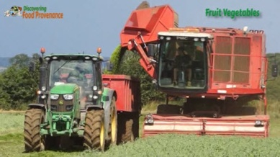 *Watch Harvesting Fresh Produce Video*

Harvesting vegetables is done in many different ways.

The veg will also be processed or treated after harvest before it reaches the shops.

Some of ways veg are harvested and treated are linked to ***(Q19)*** **_________________________**( **Choose from:** how much time we have, how much they cost, sustainability and environmental issues, )

Some of these issues are due to how the modern retailer and consumer expect their food to be provided and presented to them.

As you watch how veg is harvested and processed ready for sale think about what you now expect of the food you buy, how it is presented to you and how ‘convenient’ you expect it to be!

Veg grown on a field scale is usually harvested on large scale using large modern high tech machines with highly skilled operators

#### Peas

Peas are harvested with a ***(Q20)*** **_________________________**( **Choose from:** tractor, combine harvester, pea viner ) – this ‘sucks up the whole plant or vine. Once inside the machine the pods are popped without squashing or even damaging the peas. The peas are collected in a tank on the machine which is tipped into a trailer ready to go to the ***(Q21)*** **_________________________**( **Choose from:**  farm, shed, shop, factory ) The rest of the vine or haulm drops out of the back of the machine. Pea viners are very high tech expensive machines – how they harvest thousands of pea pods without damaging the peas inside is just amazing!

#### Sprouts

Brussels Sprouts are harvested by a different machine. This machine uses 2 very skilled operators who steer the machine ***(Q22)*** **_________________________**( **Choose from:** with their hands, automatically, with their feet ) to cut the sprout stalk off at the ground. They then feed the stalk with sprouts still attached into the machine where the sprouts are stripped off. The sprouts are then taken back to the farm for further processing.

#### Carrots, Parsnips Beetroot

As we saw at planting, carrots parsnips and beetroot are grown in ***(Q23)*** **_________________________**( **Choose from:**  rows, fields, beds ) and harvested a bed at a time. This harvester digs the root veg up along with the soil and then shakes and lets the soil drop through back on to the field. The beetroot, carrots or parsnips and placed into a trailer.

The harvested produce is then either processed straightway or stored for later use – more on this later....

#### Hand harvesting

Some crops such as cabbage, cauliflowers are harvested largely by hand

#### Glass house harvesting

Produce grown in glass houses are harvested by hand – just as they become ripe. The harvesters are very good at assessing when these are just about ***(Q24)*** **_________________________**( **Choose from:** grown, big enough, ripe ) and at the correct size so that when they arrive in the shop a day or so later they are at their best for you to eat.

Cucumbers being harvested

The cucumber must be within certain limits of size and shape ie not bent! To satisfy the consumer – experienced pickers can do this by eye with just the occasional check

Tomatoes being harvested. This machine tests the ***(Q25)*** **_________________________**( **Choose from:**  water, seed, fat, sugar ) content – the higher the sugar the better the tomato tastes.

You should not store tomatoes in the fridge as below 5 0C the sugar changes to ***(Q26)*** **_________________________**( **Choose from:** water, sugar, acid ) and spoils the sweet taste of a ripe tomato

### Primary Processing

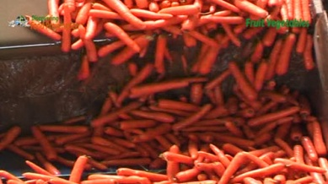 *Watch Primary Processing Fresh Produce Video*

Before it reaches your plate fresh produce often undergoes primary processing. This may be as simple as this trimming of cauliflower as it is harvested..... to make the produce more appealing and attractive to the consumer.

There are several reasons food undergoes such primary processing.

Some have implications for the environment and the sustainability of our food production – the ‘problems’ off man with food. Think about these as we look at some of the primary processing fresh produce undergoes.

#### Washing

Root veg such as potatoes, carrots and parsnips are ***(Q27)*** **_________________________**( **Choose from:**  shaken peeled, weighed, washed ) to remove soil, stones insects and any other contamination.

This makes them more convenient for the consumer but uses large amounts of water which must be dealt with after use. You can still buy ***(Q28)*** **_________________________**( **Choose from:**  normal, ‘mucky’ orange, English) carrots from local farms and shops!

#### Sorting or Grading

As well as being washed root vegetables are graded at the same time.... damaged and diseased produce is removed...

As are small or misshaped ones....

Other produce such as tomatoes, cucumbers, and tomatoes and graded as they are packaged ready for the shop....

Any damaged and diseased produce is removed... this is important for removing any disease or damaged produce making it safe, appetising and palatable to eat.

Small or misshaped ones.... are also generally removed which are fine to eat but are perceived as ***(Q29)*** **_________________________**( **Choose from:**  less value for money, not suitable to eat, less appealing ) and attractive to consumers.

The campaign to reduce food waste by encouraging us to eat ‘ugly veg that are still safe healthy and nutritious is trying to address this.

#### Wrapping and Labelling

Once washed if required and graded the fresh produce is then labelled and wrapped or packaged....

Packaging can be important in keeping the food ( dry, in a bunch, safe to eat, easy to carry) as well as making it appealing and attractive to consumers. It does have implications for environment because of the use of ***(Q30)*** **_________________________**( **Choose from:**  chemicals, cheap labour, non-renewable energy resources, plastic) to make it and its disposal afterwards.

It is up to the consumer to decide the amount of packaging that is sustainable and let the food retailers know!

#### Storing

The storing of all harvested produce for a period of time is a requirement of the modern food production system when a whole year’s crop output is ripe and ***(Q31)*** **_________________________**( **Choose from:**  tasty, colourful, ready for harvest safe to leave) in a very short time window.

Sometimes ‘ripe’ produce can be ‘stored’ by simply not harvesting it.

Like these Cabbages which can also be ‘stored’ ***(Q32)*** **_________________________**( **Choose from:**  in boxes, in large sheds, frozen, growing in the field.) They are just harvested as required over the winter.

Carrots are more susceptible to inclement weather such as frost but can still be ‘stored’ in the ground where they grew. They just need covering with straw to protect them from ***(Q33)*** **_________________________**( **Choose from:**  sun, wind, rain, frost) . They can then be harvested over winter when needed.

Some produce such as sprouts, broccoli and these peas can be stored for long periods by deliberately ***(Q34)*** **_________________________**( **Choose from:** washing , cooking, freezing, storing) them in a way that preserves rather than destroys them.

Another development of primary processing is that it has allowed us to wash, sort grade and package food in such a way that we can transport it around the world such that the foods remain safe, appetising, palatable, appealing attractive, convenient easy to store and use.

No longer are we depend on locally grown seasonal fruit and vegetables it can be transported around the world in no time…. But as we have tried to illustrate and make you think – this choice and availability has consequences in terms of the environment, food security and the sustainability of continued food production.

*Using the key words in the box* ***(some can be used more than once)*** *to explain in your own words how growers are working to produce food and at the same time protect the environment.*

**Integrated, pests and disease, seasonally, field, glass houses, environment, isolated from outside, biological, carbon neutral, CHP unit, photosynthesis, carbon dioxide, heat and light, today’s technology, seasonal food, consumer, acceptable.**

*You could start with…*

*Fresh produce can be grown .......*